# Diary Development Notes

Week 1

## Monday (7-Novmeber-2022)

* Explore the unit guideline and MS Team
* Find a company that I wish to join and contribute by filling up the google form providing by the unit chair.

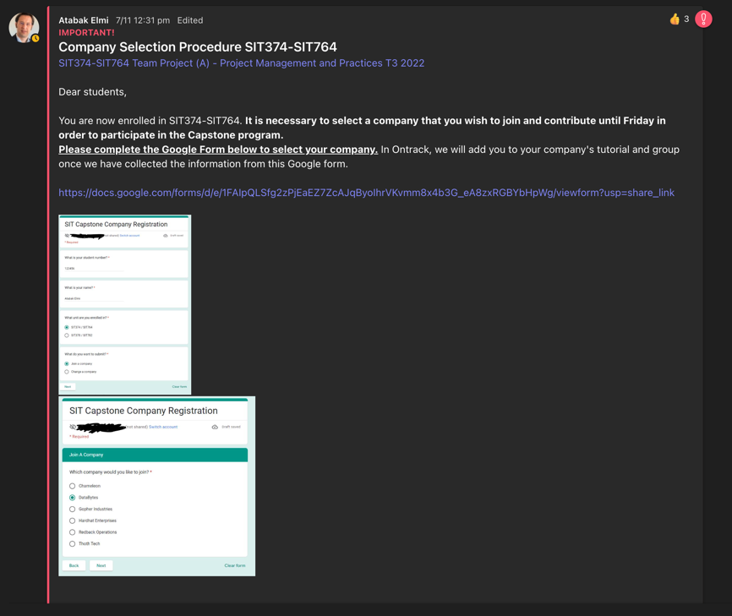

Figure : Announcement from the unit chair related to the Company Selection

## Thursday (10-November-2022)

* Join the Week 1 Lecture Class

Week 2

## Monday (14-November-2022)

* Assign to Gopher Industry and work in the Team Avengers

## Tuesday (15-November-2022)

* Get familiarise with the team environment and review some of the previous document from T2 such as project handover document and video demonstration.

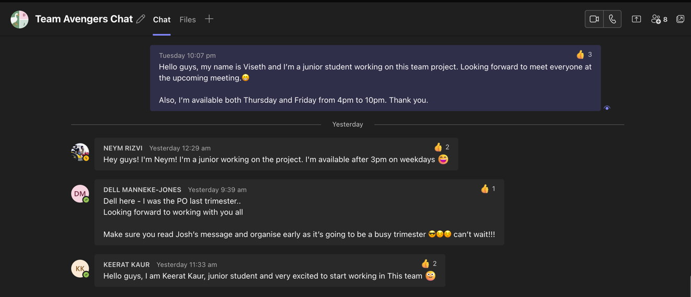

Figure : Welcome message from the Team Avengers and the Senior members

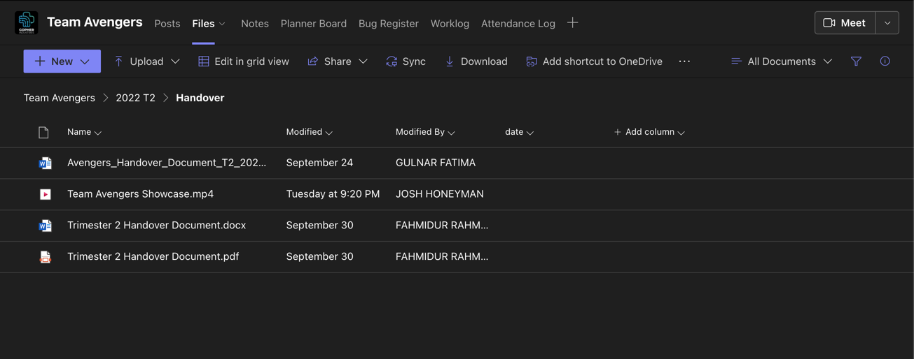

Figure : Handover document folder from previous trimester that I need to review

* Set up worklog and Attendance log by entering my student details

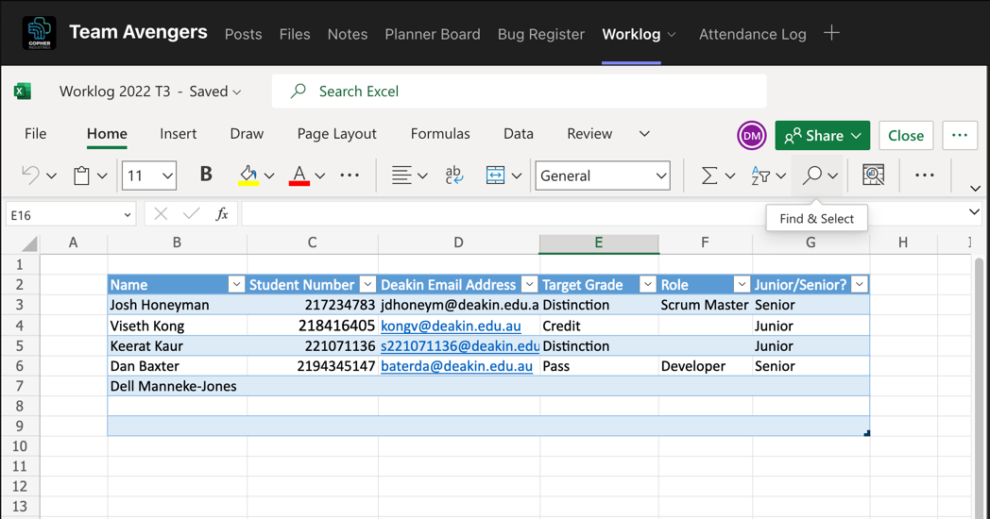

Figure : Our team worklog and attendance log for this trimester

## Wednesday (16-November-2022)

* Interact with Medi Chatbot on the test website <https://gopherindustries.webnode.page/>

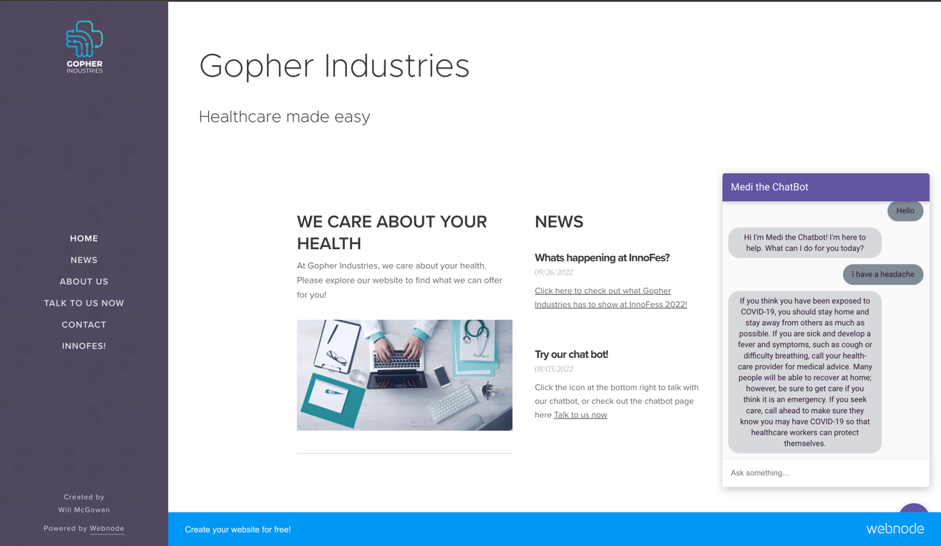

Figure : Testing the chatbot that were built from the previous team members

* Learning through the Google Developers course called Building Chatbots with Dialogflow recommended from the senior members

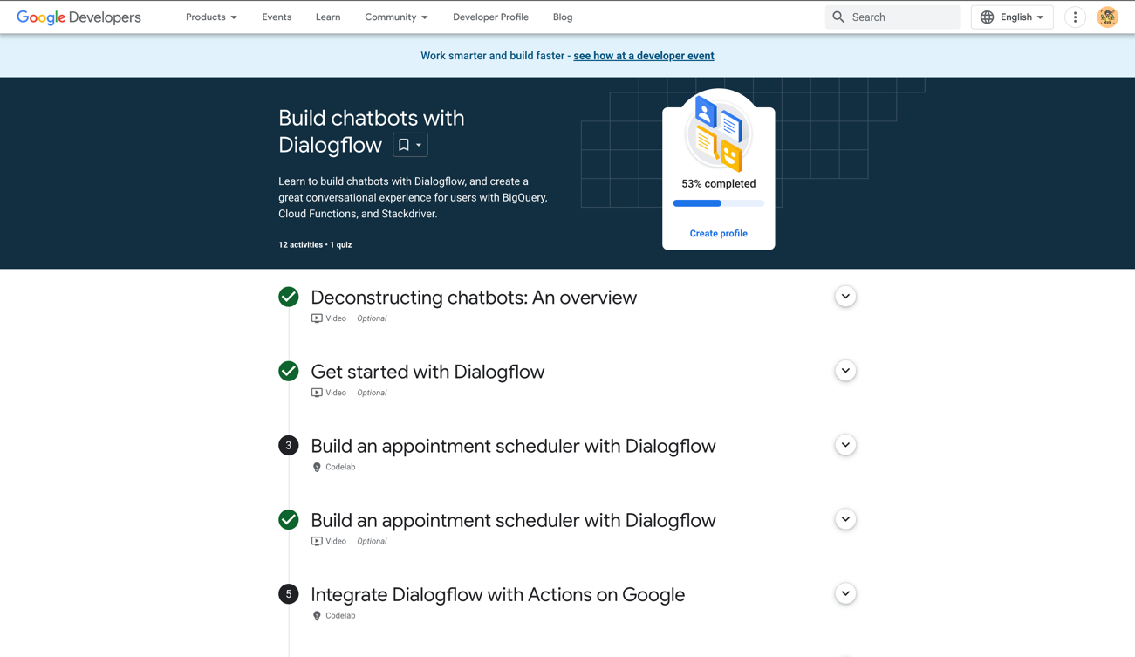

Figure : Learning how to build chatbots with Dialog

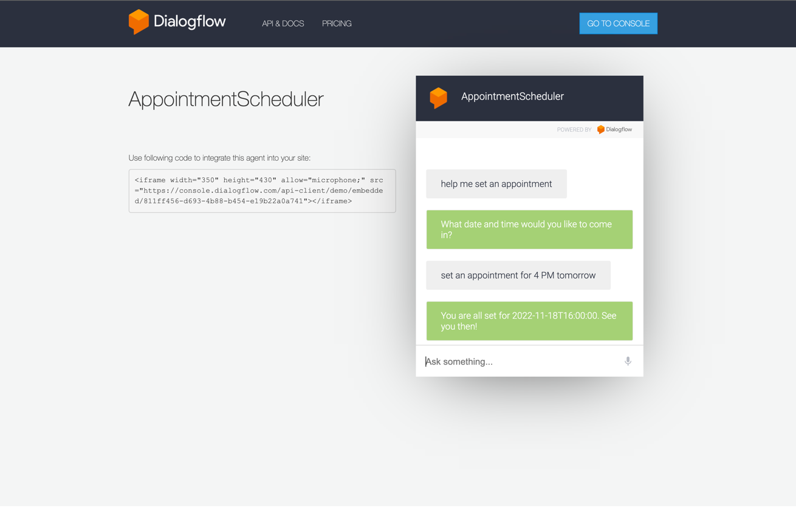

Figure : Testing my first Chatbot on Web Demo

* Complete task 1.1p and 2.1c

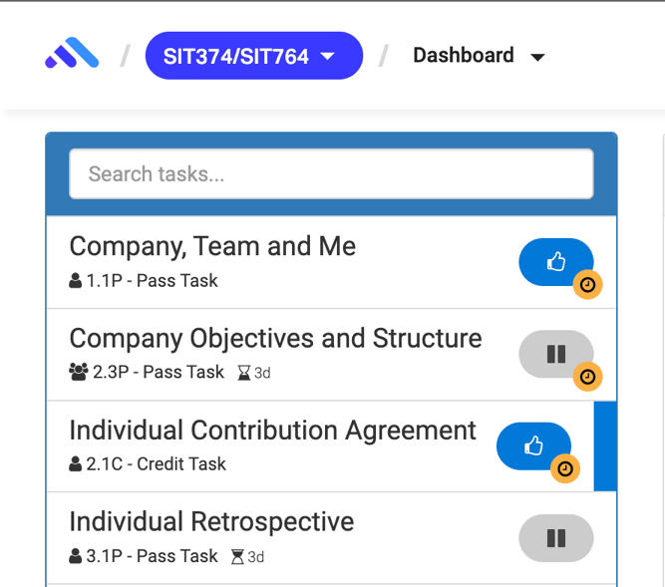

Figure : Submit tasks on Ontrack

## Thursday (17-November-2022)

* Join the Week 2 Lecture Class
* Join Surviving Capstone Meeting - Tips and Tricks from a Capstone Senior

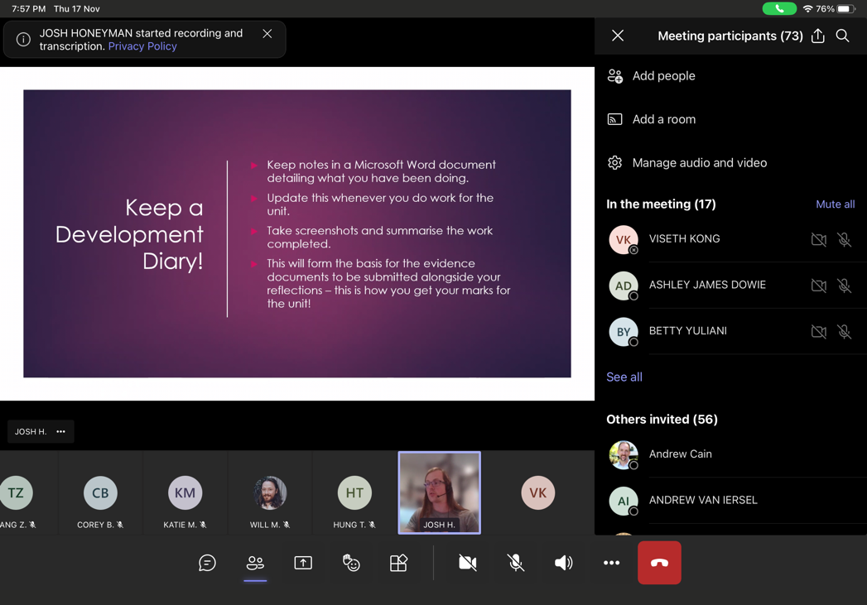

Figure : Meeting with Gopher Company

* Reply to senior member related to the meeting appointment issues

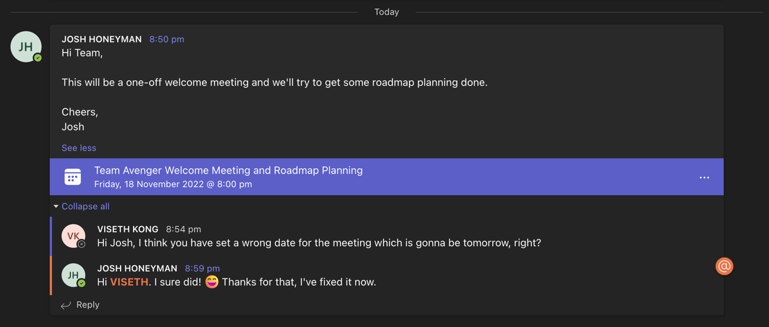

Figure 10: Reminded Josh when he set a wrong date for the meeting

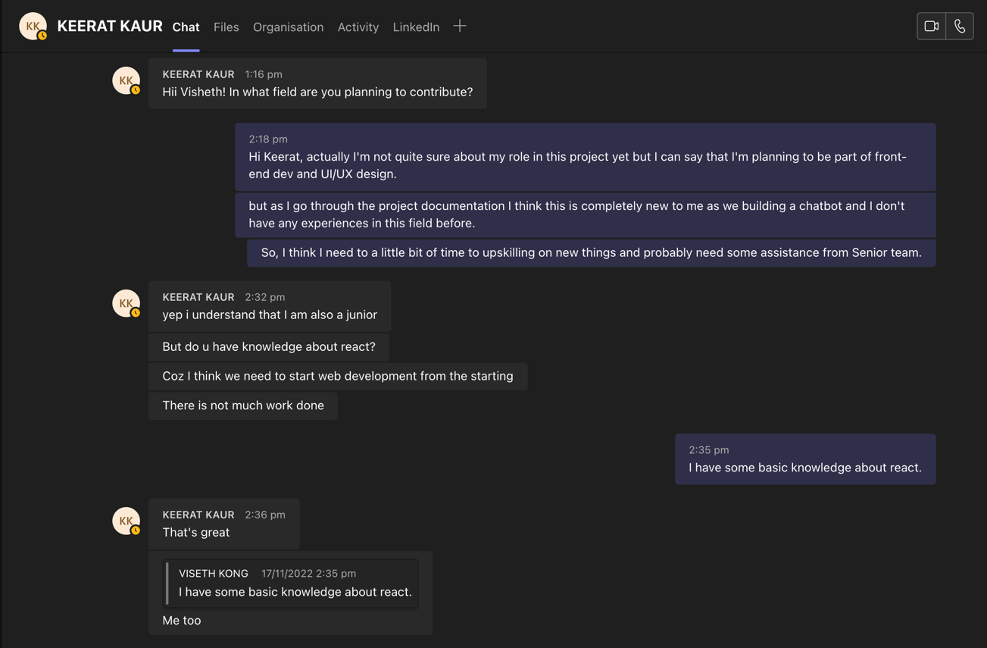

Figure 11: Have some conversation with other junior member about the role in the project

## Friday (18-November-2022)

* Continue learning through the Google Developers course called Building Chatbots with Dialogflow

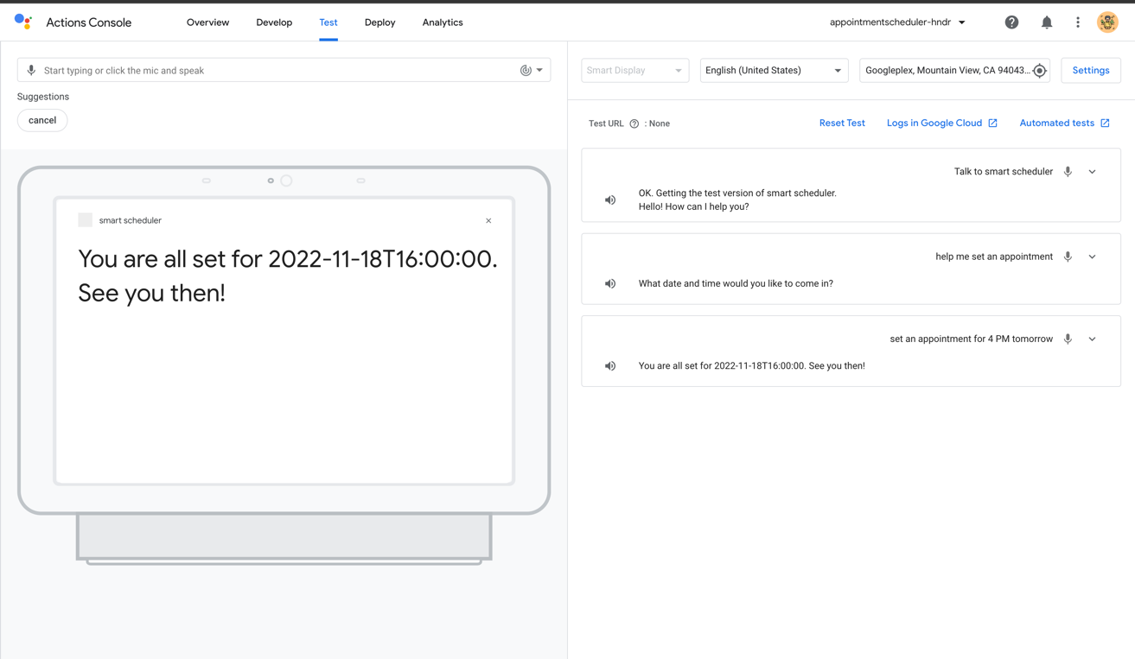

Figure 12: Integrate a Dialogflow Chatbot with Actions on Google

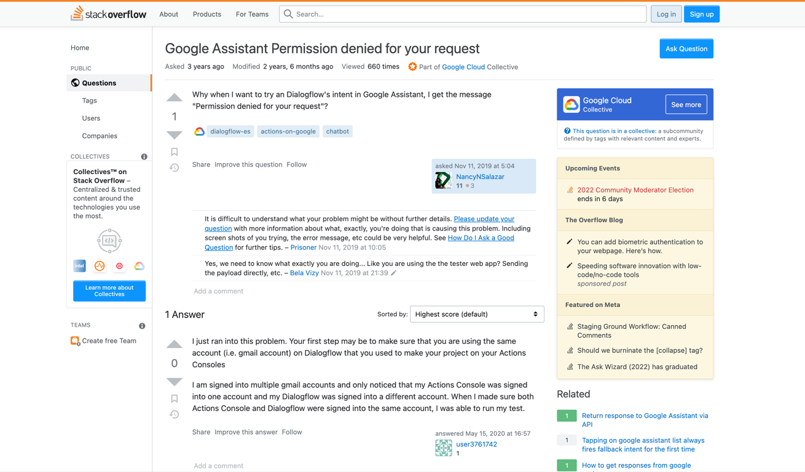

Figure 13: During my upskilling, I have encounter some issues and solve them successfully

* Research and found some essential resources related to the project

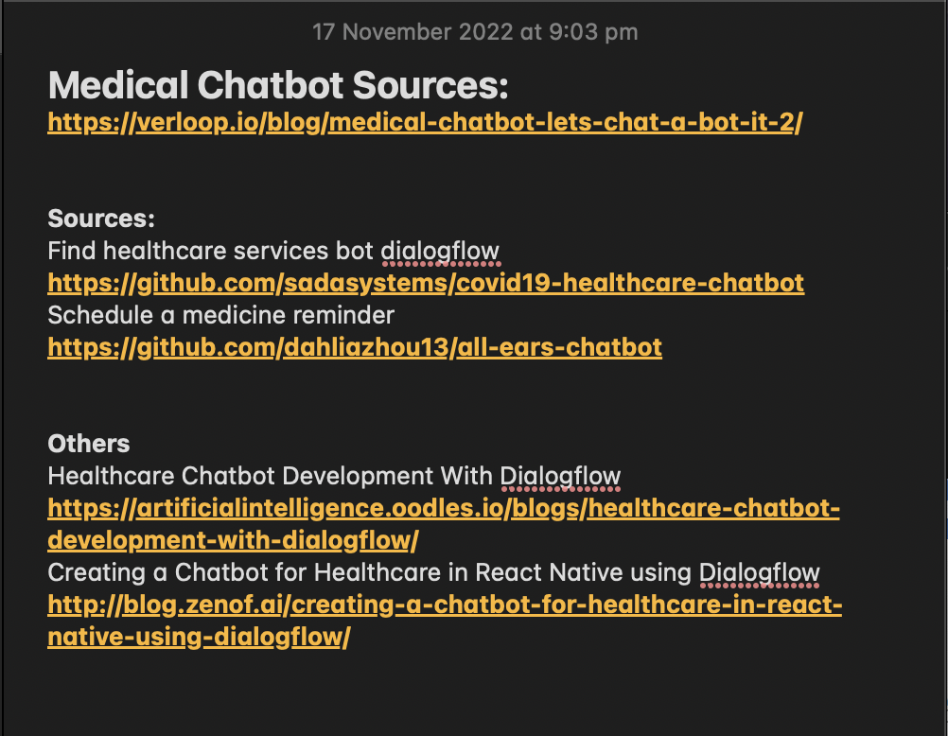

Figure 14: Some resources I found in google which related to my project

## Saturday (19-November-2022)

* Completed Ontrack task 1.1P and 2.1C

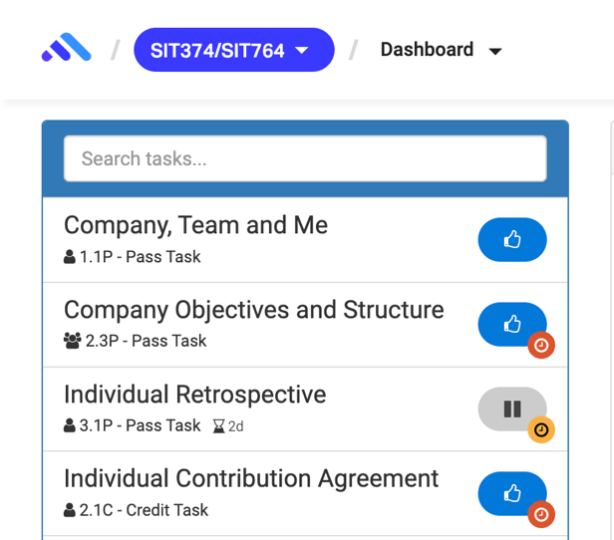

Figure 15: Ontrack Submission

Week 3

## Monday (21-November-2022)

* Join Sprint planning Meeting with Team Avengers.
* Learn how to use GitHub and Git command to clone, add, commit and push.

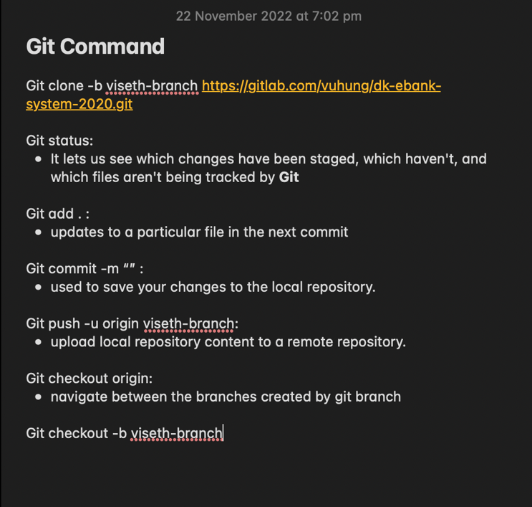

Figure 16: Git Command Notes

* Research on how to stream audio input to a detect intent request using the API.
* Read through the Github project related to speak-to-text function: <https://github.com/dialogflow/selfservicekiosk-audio-streaming/>
* Testing speak-to-text demo from the Github project: <http://selfservicedesk.appspot.com/>
* Link to article resources:
  + <https://cloud.google.com/dialogflow/es/docs/how/detect-intent-stream>
  + <https://cloud.google.com/dialogflow/es/docs/how/detect-intent-tts>
  + <https://princekfrancis.medium.com/dialogflow-detect-intent-with-streaming-from-mic-and-output-as-streaming-into-speaker-88b4166fca43>

## Tuesday (22-November-2022)

* Learn Node.Js fundamental through YouTube and various website.
* Learn how to use Google Cloud console and Google SDK to create credential and enable service account.

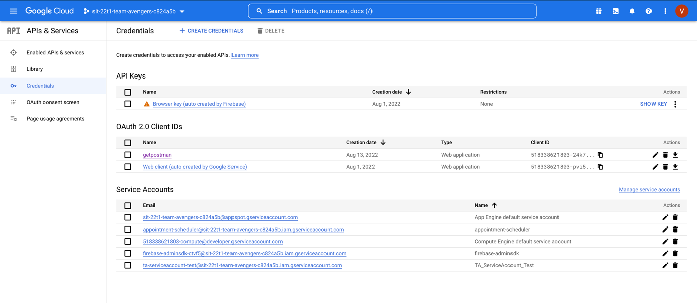

Figure 17: Google cloud console with Team avengers project to use DialogFlow

* Continue my research on audio input to a detect intent
* Join Daily Scrum meeting with Team Avengers
* Share a few resources that I have found with the team

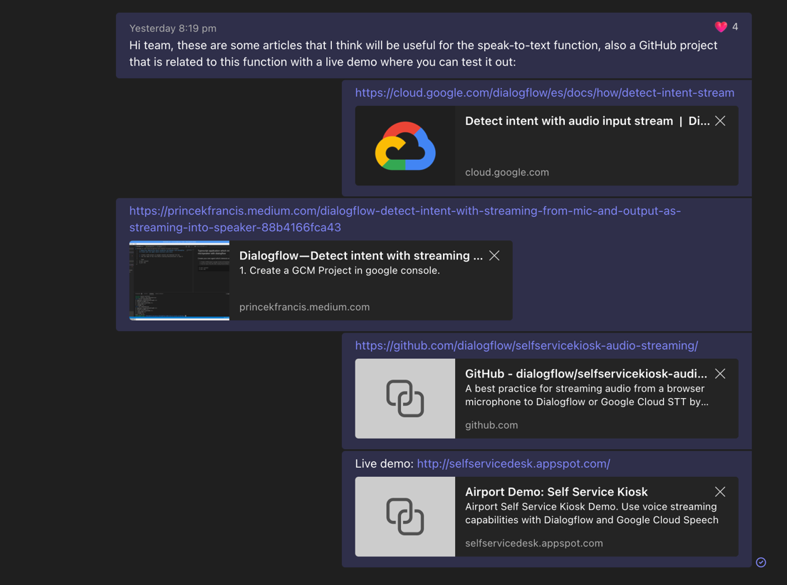

Figure 18: Share resources in the group chat

## Wednesday (23-11-2022)

* Join a meeting with the Project X team member (Nathan) regarding to the chatbot and company website integration.

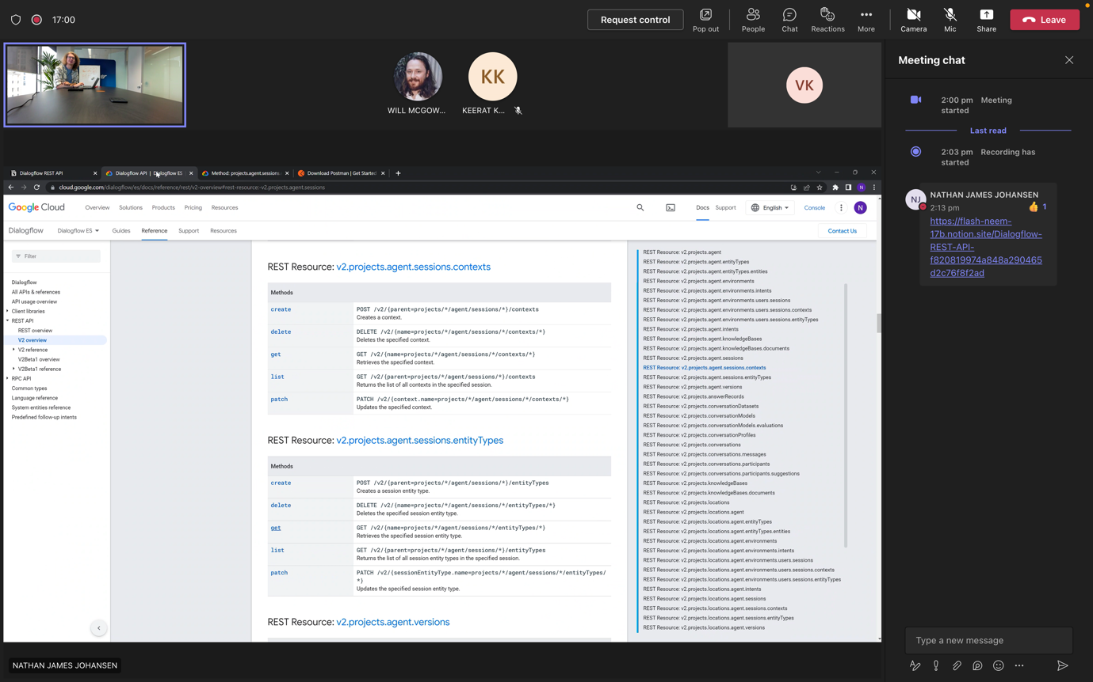

Figure 19: Meeting with Nathan from Team Project X

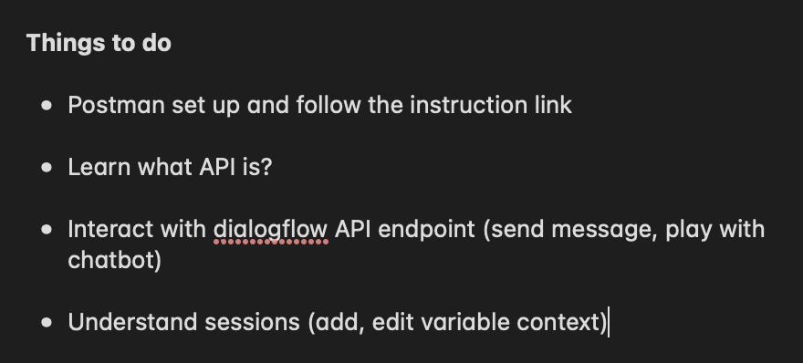

Figure : Notes on things I need to work on during the meeting with Nathan

* Join another meeting with Keerat (Junior student) regard to the assigned task and have some conversation regarding to the role

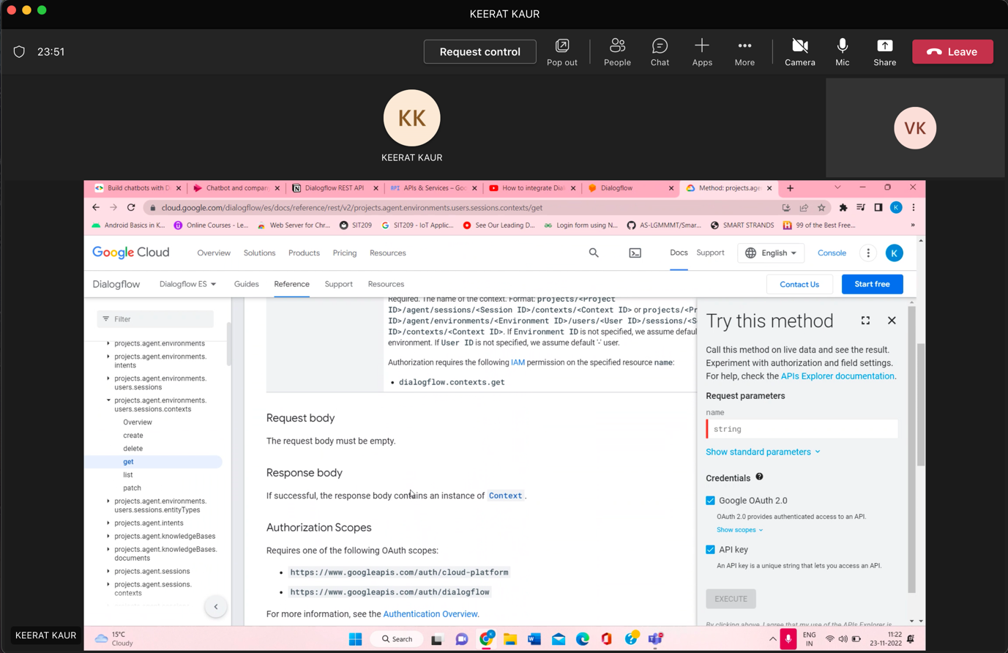

Figure 21: Meeting with Keerat about the assigned task

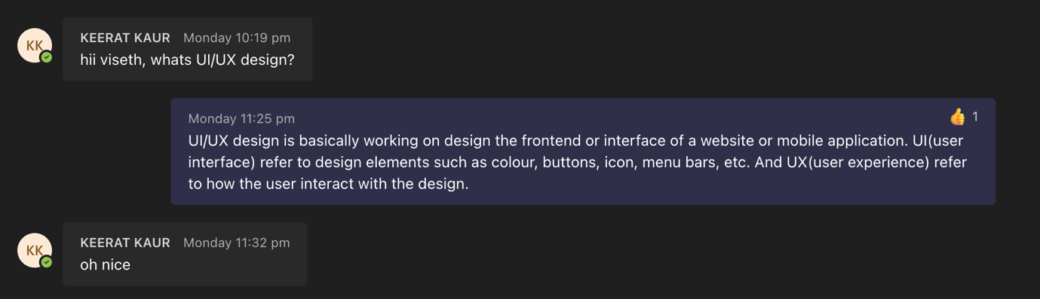

Figure 22: Have some conversations with Keerat

* Working on Dialogflow REST API by connect it with Postman but with my personal project

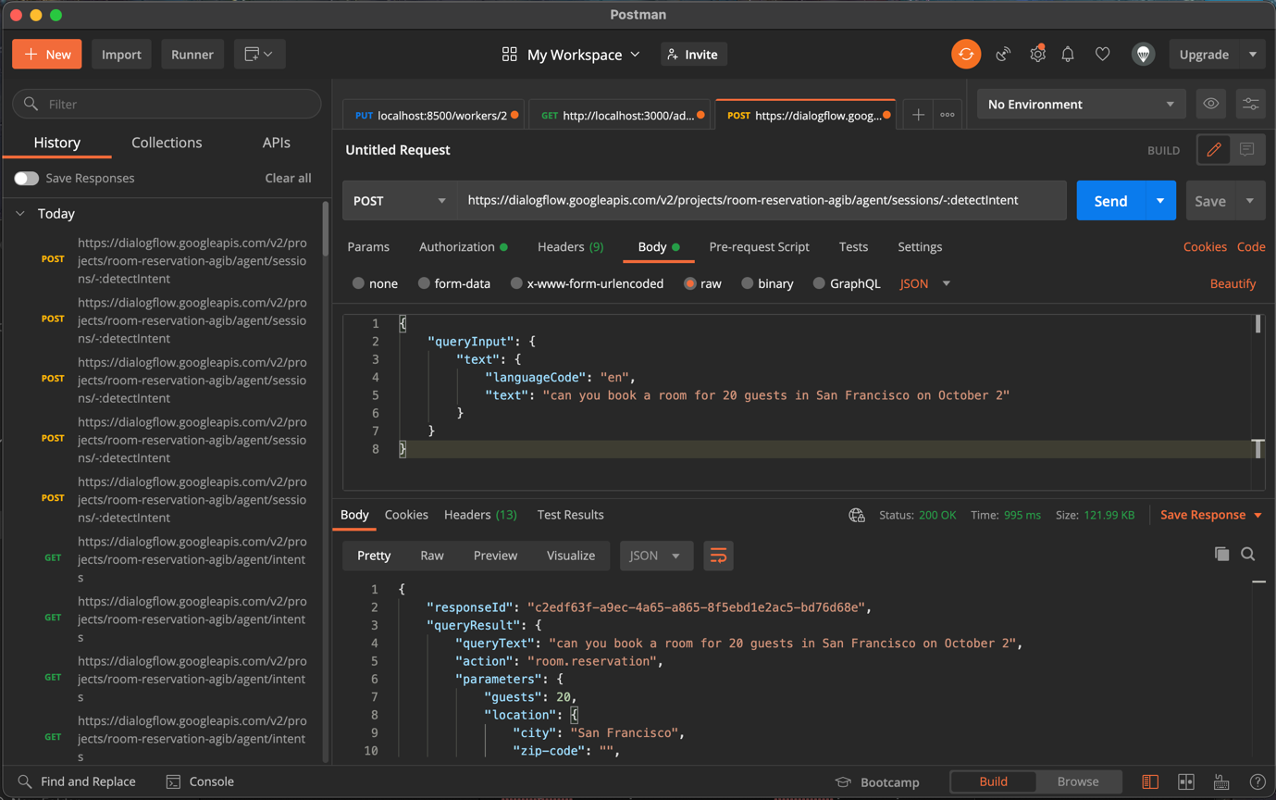

Figure 23: Connect DialogFlow API to Postman to and able to send queries

* Research on Integrating A Dialogflow Agent Into A Web Application: <https://www.smashingmagazine.com/2021/01/dialogflow-agent-react-application/>

## Thursday (24-11-2022)

* Join a meeting with Keerat about the Postman issues

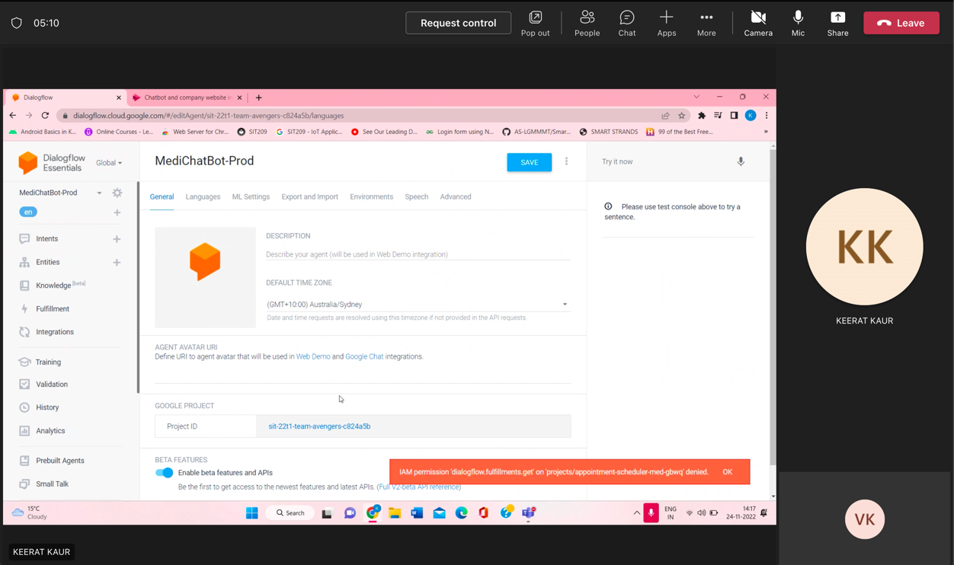

Figure 24: Meeting with Keerat

* Join Daily Scrum Meeting
* Join a Meeting with Nathan from team project X regarding to Postman Trouble Shooting

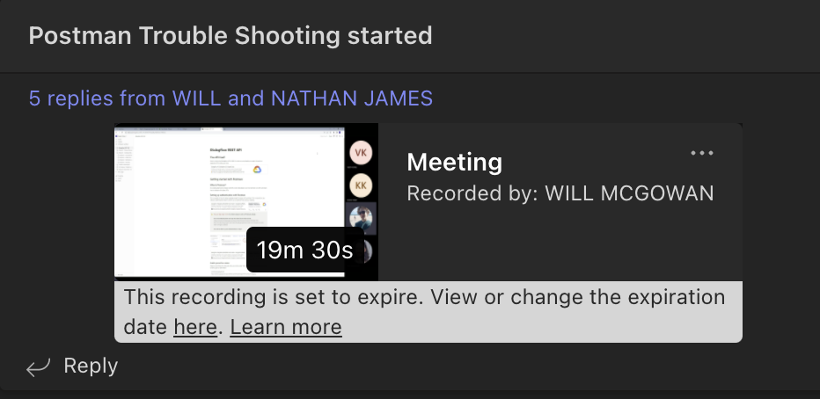

Figure 25: Postman Trouble Shooting Meeting

* Try to fix Postman unauthenticated and Google credential

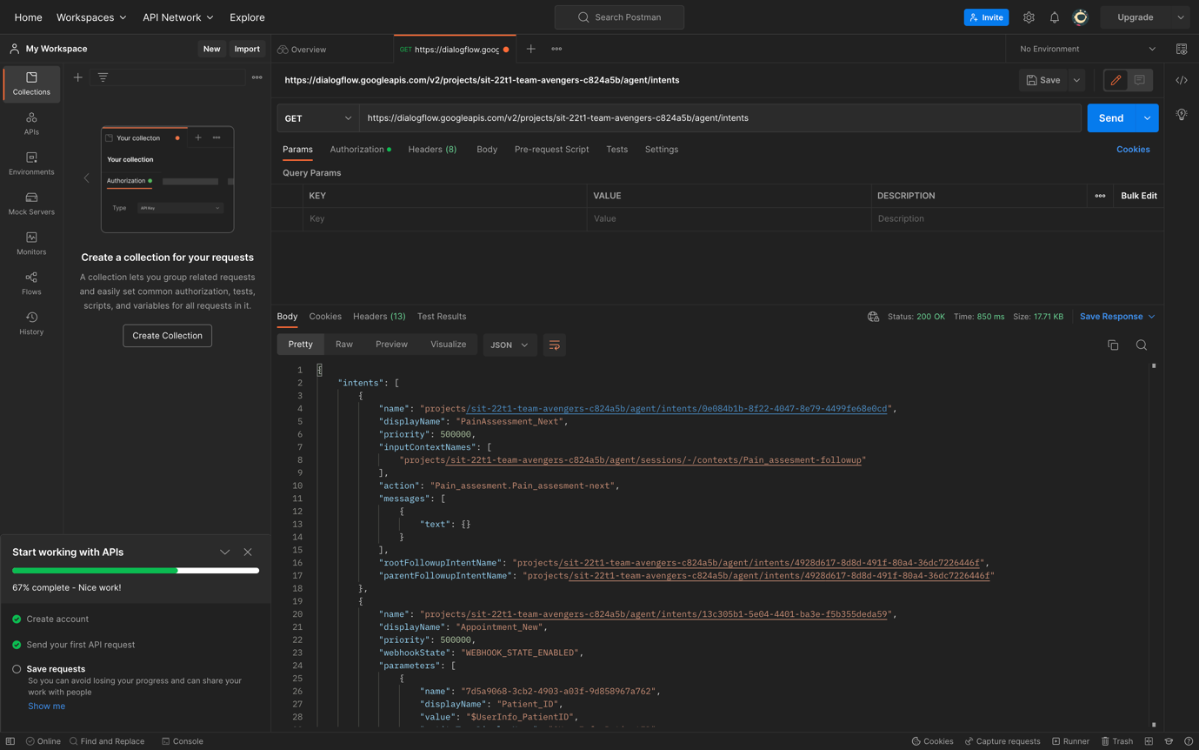

Figure 26: Connect Team project DialogFlow API with Postman

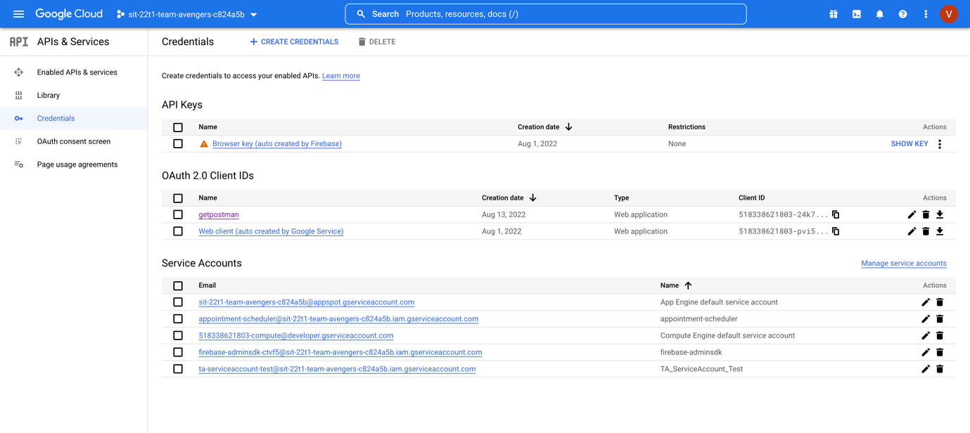

Figure 27: Google API and credential of team avengers

* Integrate chatbot into a simple website

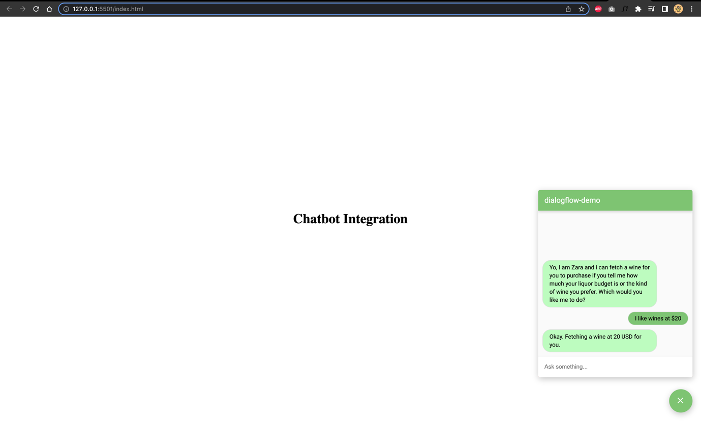

Figure 28: DialogFlow chatbot in a static website

* Learn to detect intent from query locally

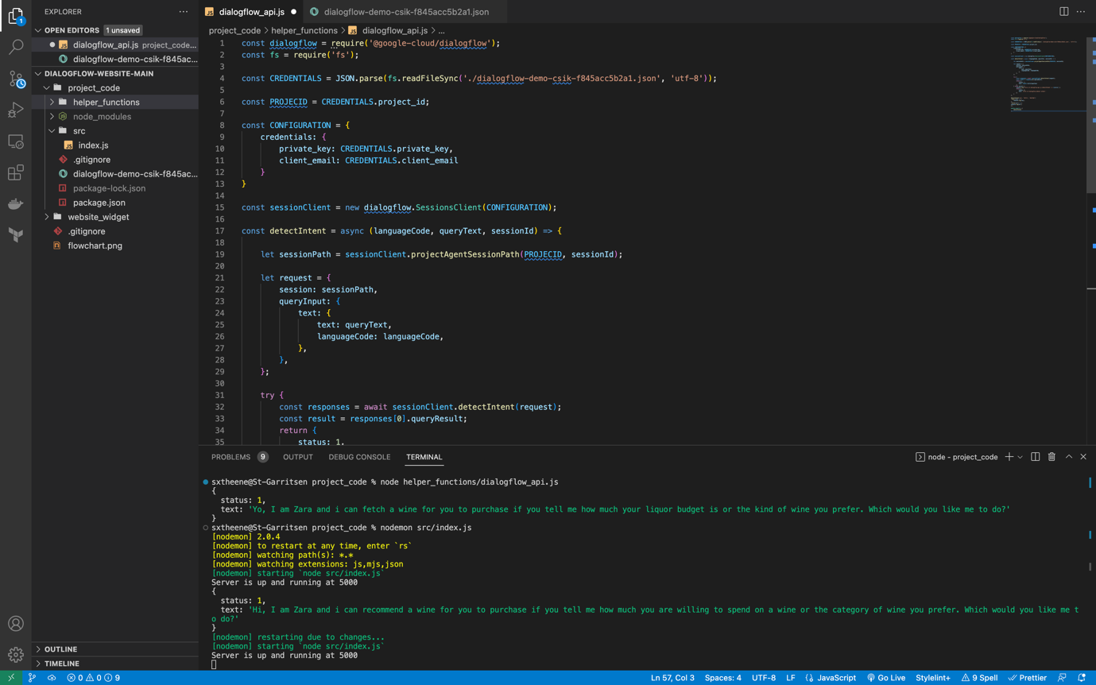

Figure 29: Able to detect intent from query in Local machine

## Saturday (26/11/2022)

* Working on Ontrack Task 3.1p and 3.2c

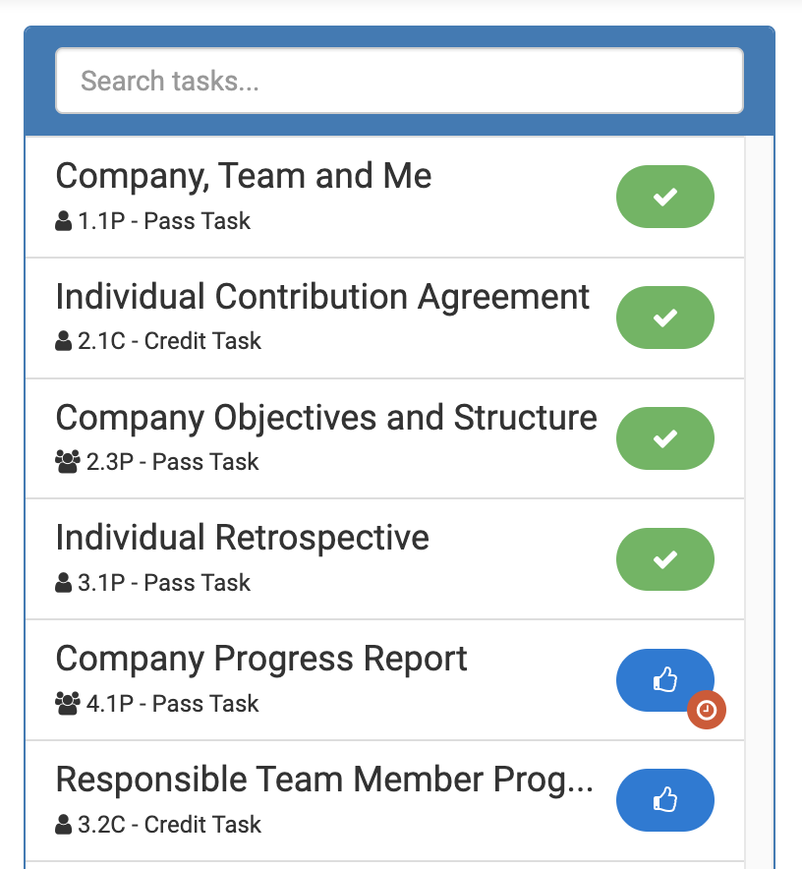

Figure 30: Ontrack task submission

## Sunday (27/11/2022)

* Join a meeting with Keerat regarding to the Postman issues and Ontrack Task

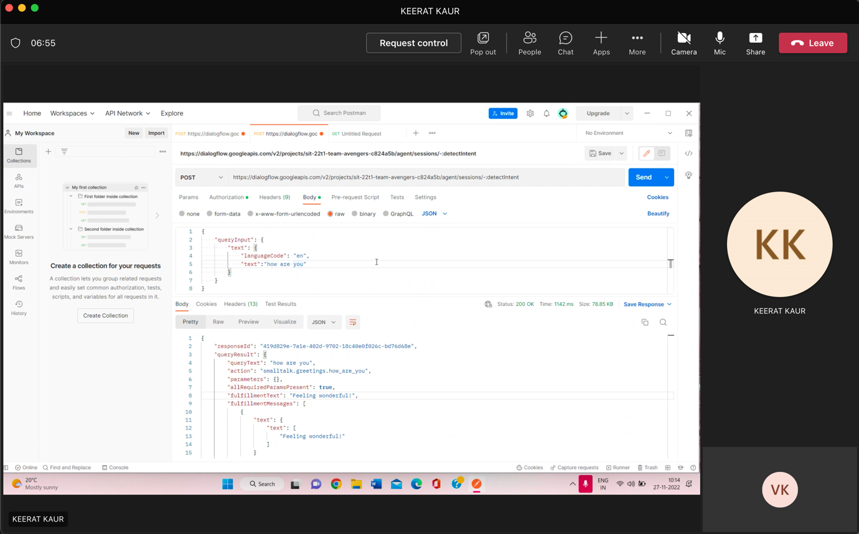

Figure 31: Meeting with Keerat about the Postman issues

Week 4

## Monday (28/11/2022)

* Join sprint planning meeting
* Create a video demonstration about DialogFlow REST API

<https://github.com/visethkong/SIT374-SIT764/tree/main/Sprint1-Video-Demo>

## Tuesday (29/11/2022)

* Join scrum meeting

## Wednesday (30/11/2022)

* Research on DialogFlow project session

<https://developers.google.com/resources/api-libraries/documentation/dialogflow/v2/java/latest/com/google/api/services/dialogflow/v2/Dialogflow.Projects.Agent.Sessions.html>

* Join meeting with Nathan from Project X team regarding to the edit context command

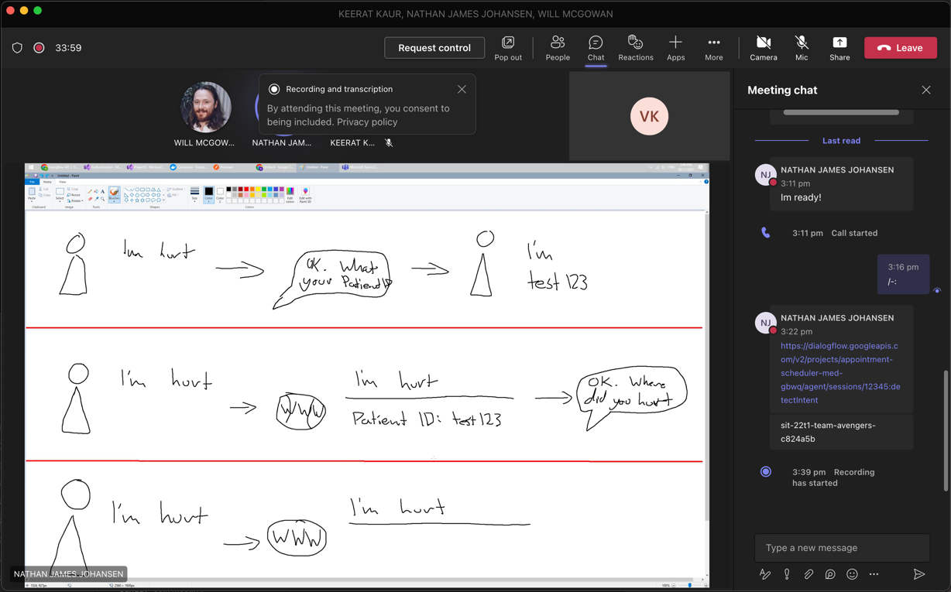

Figure 32: Meeting with Project X team member

* Research on How to edit context in Postman

<https://cloud.google.com/dialogflow/es/docs/reference/rest/v2/projects.agent.sessions.contexts/patch>

* Join a meeting with Keerat regarding to the assigned task
* Join scrum meeting
* Working on edit/update command in Postman

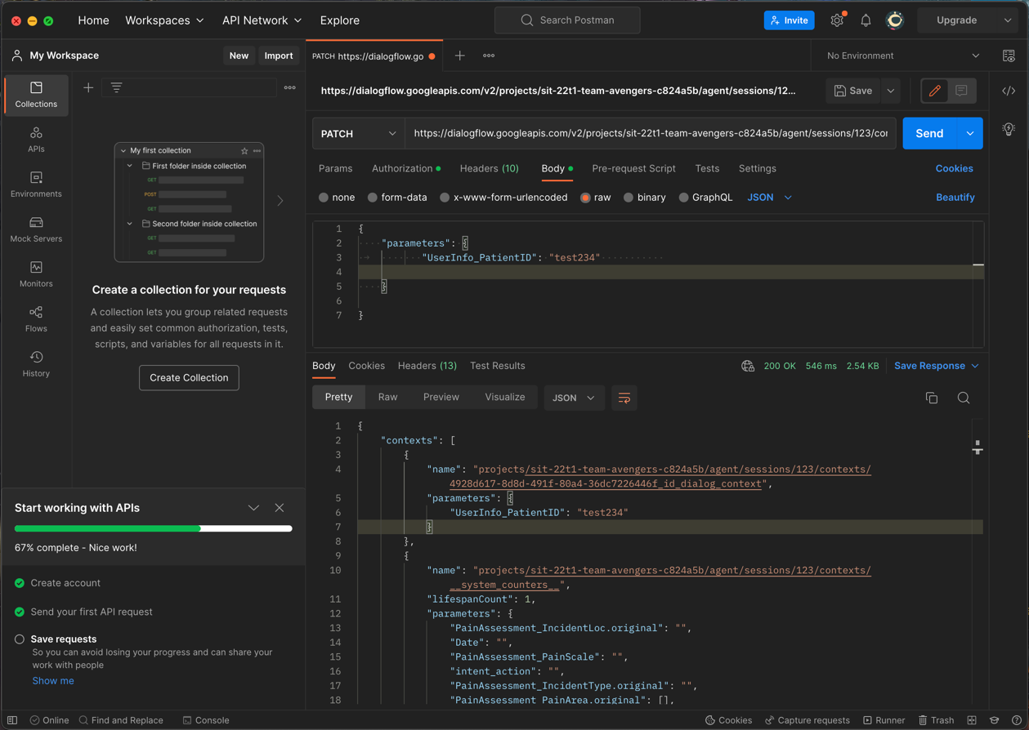

Figure 33: edit/update command in Postman

## Thursday (01/12/2022)

* Research on API query on how to edit or update variable
* Meeting with Keerat to solve some issues regard to the assigned task

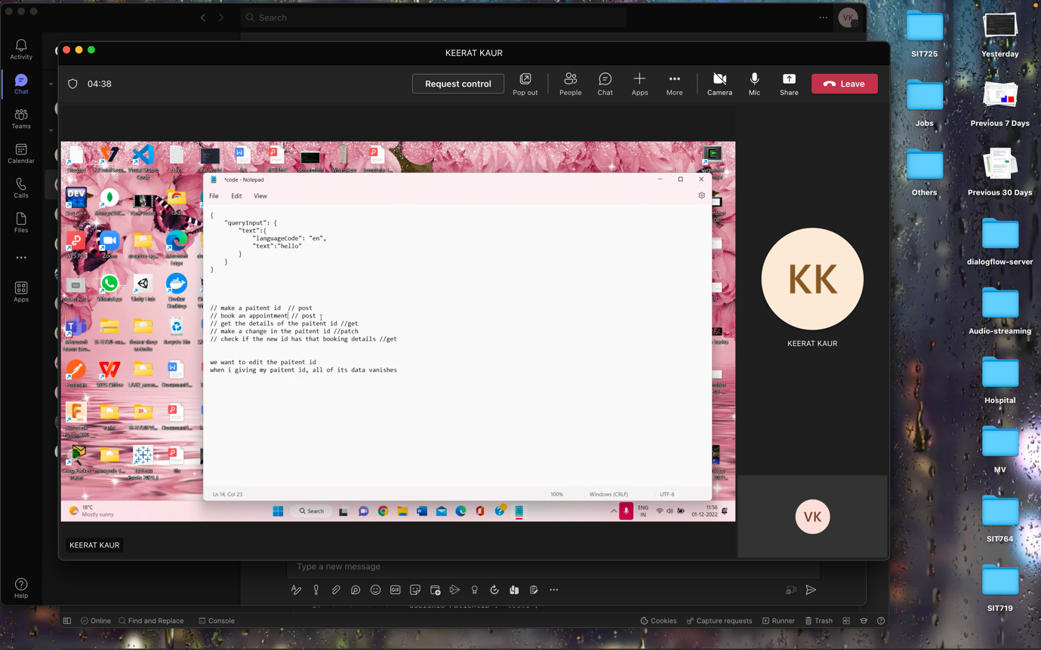

Figure 34: Meeting with Keerat to solve issues

* Research on Google Firestone Database

<https://firebase.google.com/docs/firestore>

* Learn on how to connect Firestone database to DialogFlow
* Get familiar with DialogFlow Database

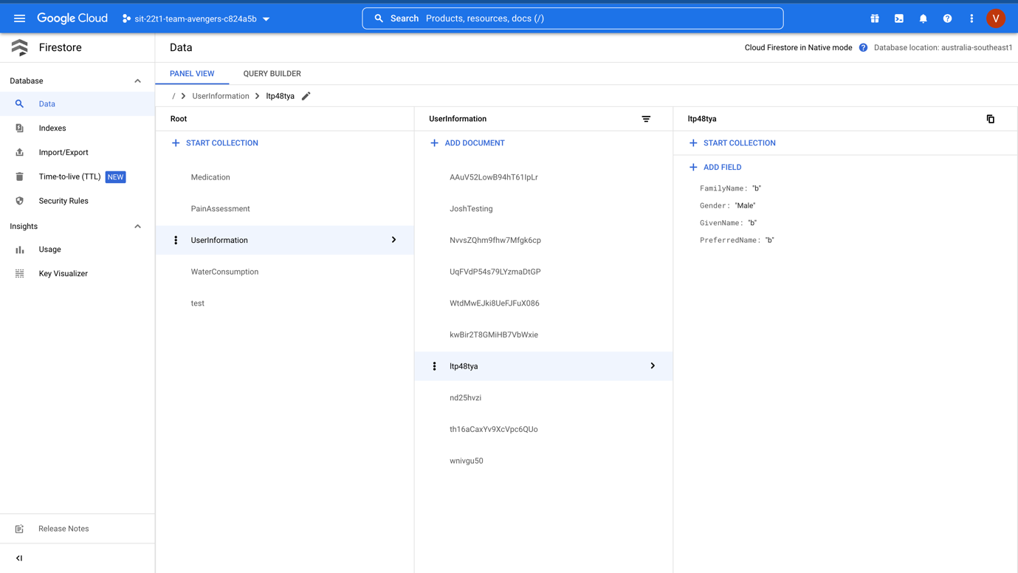

Figure 35: Team Avengers Firestore Database

* Attend Week 4 Lecture class

## Saturday (03/12/2022)

* Meeting with Keera to discuss how we update the patient ID
* Working with Postman and Dialogflow REST API document

<https://cloud.google.com/dialogflow/es/docs/reference/rest/v2-overview#rest-resource:-v2.projects.agent.sessions>

## Sunday (04/12/2022)

* Continue working with postman regarding to the update the patient ID session
* Able to solve the session issues with the Patient ID

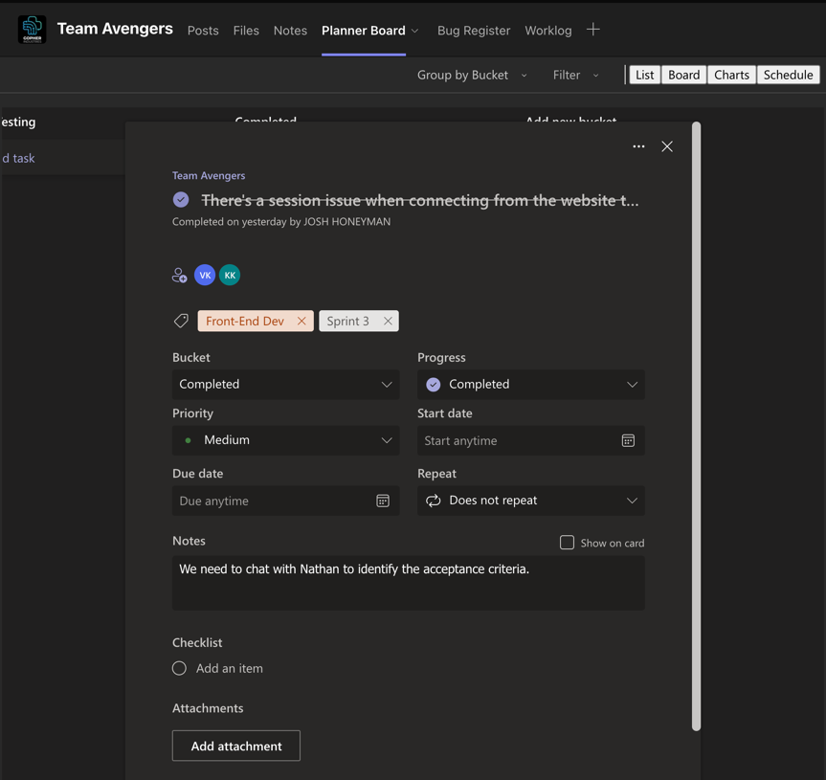

Figure 36: Completed the assigned task for sprint 2

* Meeting with Nathan from Project X team member to show our demonstration

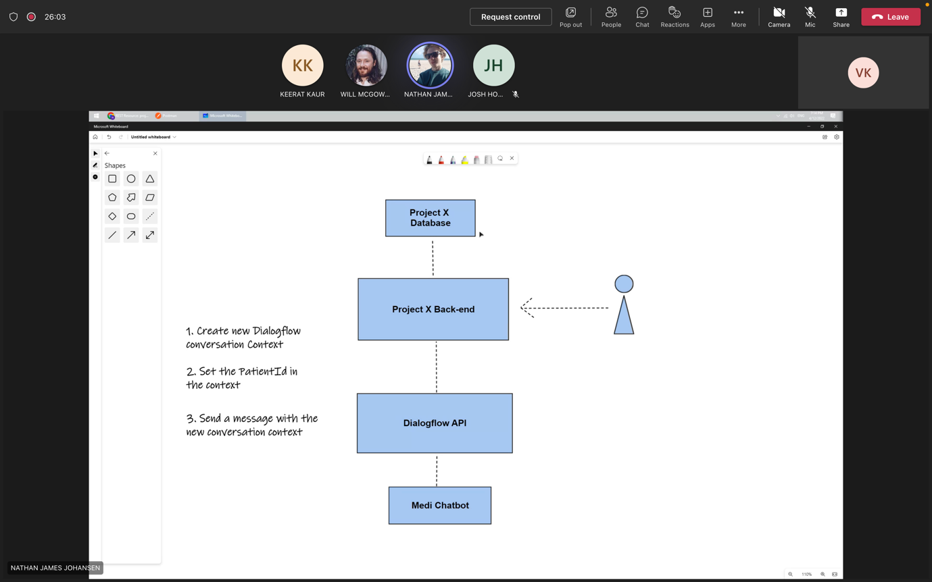

Figure 37: Meeting with Nathan about the next task

Week 5

## Monday (05/12/2022)

* Join Sprint planning meeting
* Create a Sprint 2 documentation

<https://github.com/visethkong/SIT374-SIT764/tree/main/Sprint2-Documentation>

* Research on CREATE method to create a context using Postman <https://cloud.google.com/dialogflow/es/docs/reference/rest/v2/projects.agent.sessions.contexts/create>
* Upskill on create Intent with context from Postman

## Tuesday (06/12/2022)

* Continue upskill on create Intent with context from Postman
* Meeting with Keerat regarding to the assigned task

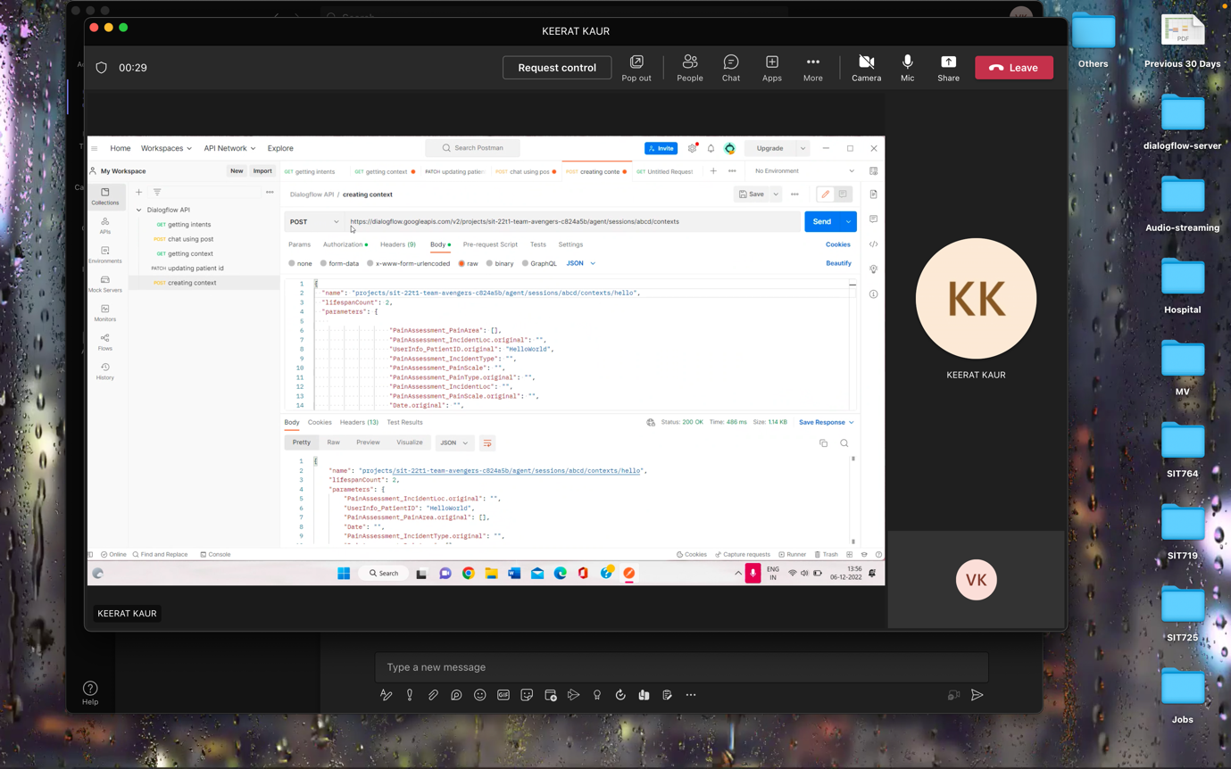

Figure 38: Meeting with Keerat

* Join scrum meeting

## Wednesday (07/12/2022)

* Testing the create context command with Postman
* Meeting with Nathan to demonstrate how we work on the assigned task

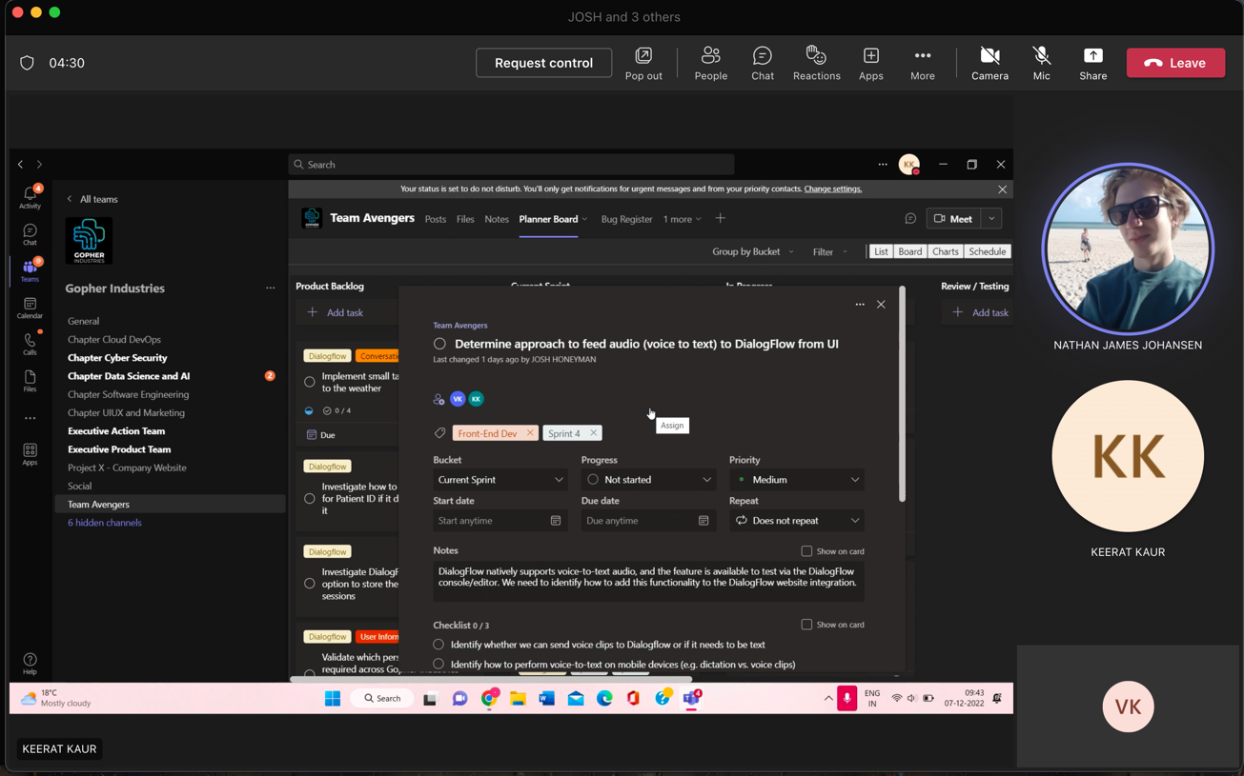

Figure 39: Discuss with Nathan regarding to the assigned task

* Meeting with Keerat to create a short video demo: <https://deakin365-my.sharepoint.com/personal/s221071136_deakin_edu_au/_layouts/15/stream.aspx?id=%2Fpersonal%2Fs221071136%5Fdeakin%5Fedu%5Fau%2FDocuments%2FRecordings%2FSprint%204%20task%2D20221207%5F102026%2DMeeting%20Recording%2Emp4&ga=1&OR=Teams-HL&CT=1670389688764&clickparams=eyJBcHBOYW1lIjoiVGVhbXMtRGVza3RvcCIsIkFwcFZlcnNpb24iOiIyOC8yMjExMzAwNDEwMCIsIkhhc0ZlZGVyYXRlZFVzZXIiOmZhbHNlfQ%3D%3D>
* Discuss with Keerat about the Speech-to-text function and share some article to the Planner board

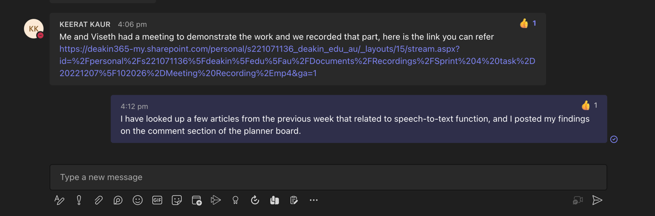

Figure 40: Notify team member about what we have done

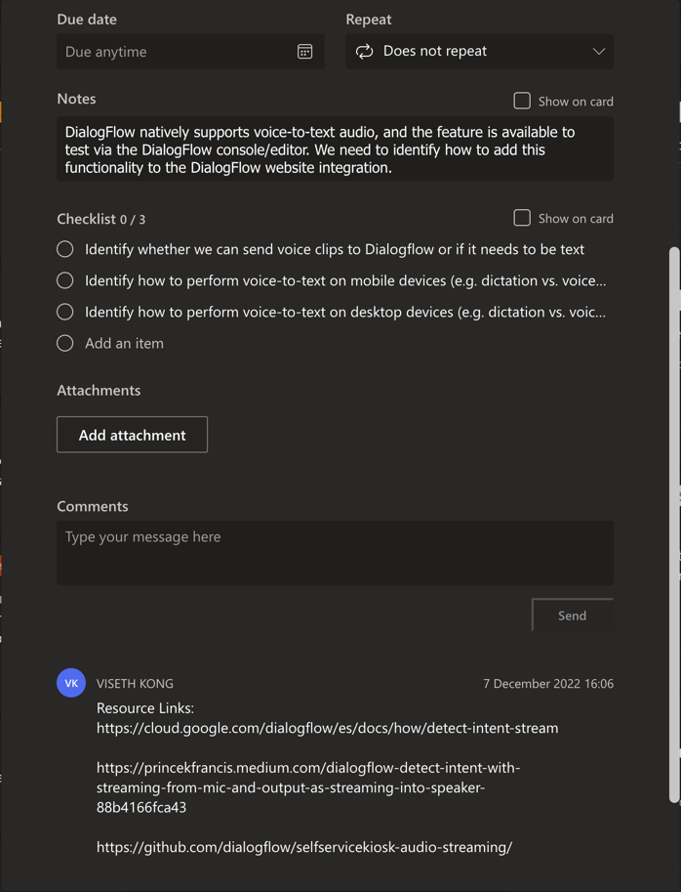

Figure 41: Adding sources to the Planner board

## Thursday (08/12/2022)

* Attend the Week 5 Lecture Class
* Join Daily Scrum Meeting
* Meeting with Keerat about the Speech-to-text function
* Working with Postman to apply Speech-to-text function

## Friday (09/12/2022)

* Join Daily Scrum Meeting
* Try to find a solution to the Postman issue

## Sunday (11/12/2022)

* Meeting with Keerat to discuss about the assigned task and documentation

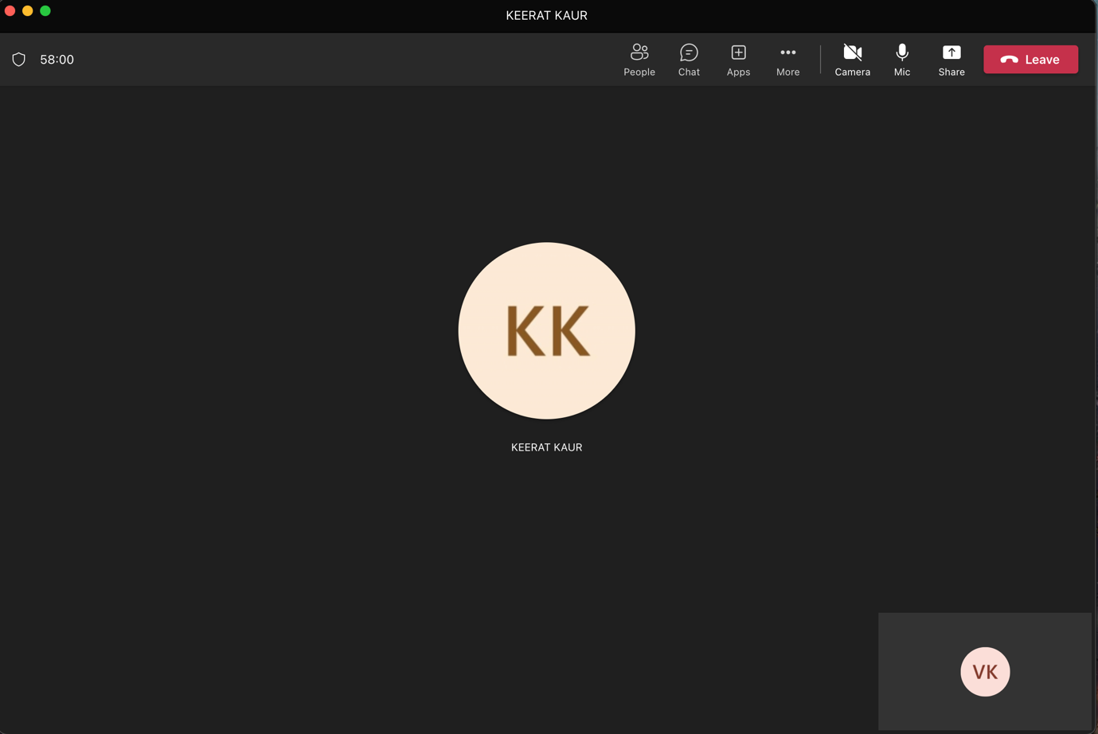

Figure 42: Meeting with Keerat for about an hour

* Research on detect intent audio stream
* Update a document for Sprint 4

Week 6

## Monday (12/12/2022)

* Join Sprint Planning Meeting
* Research on Postman for recorded audio files

<https://symbl.ai/blog/get-started-with-postman-for-recorded-audio-files/>

* Use Postman to generate a transcription from an audio recording

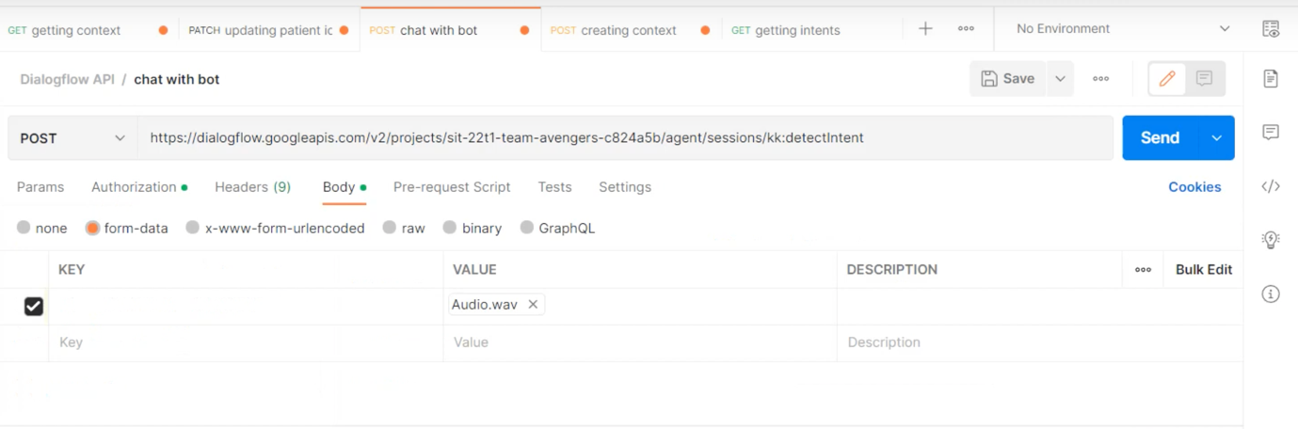

Figure 43: Adding Audio file to Postman

* Continue working on the document for sprint 4

## Tuesday (13/12/2022)

* Join Daily Scrum Meeting

## Wednesday (14/12/2022)

* Join a meeting with Keerat to discuss about the Speech-to-text function issues

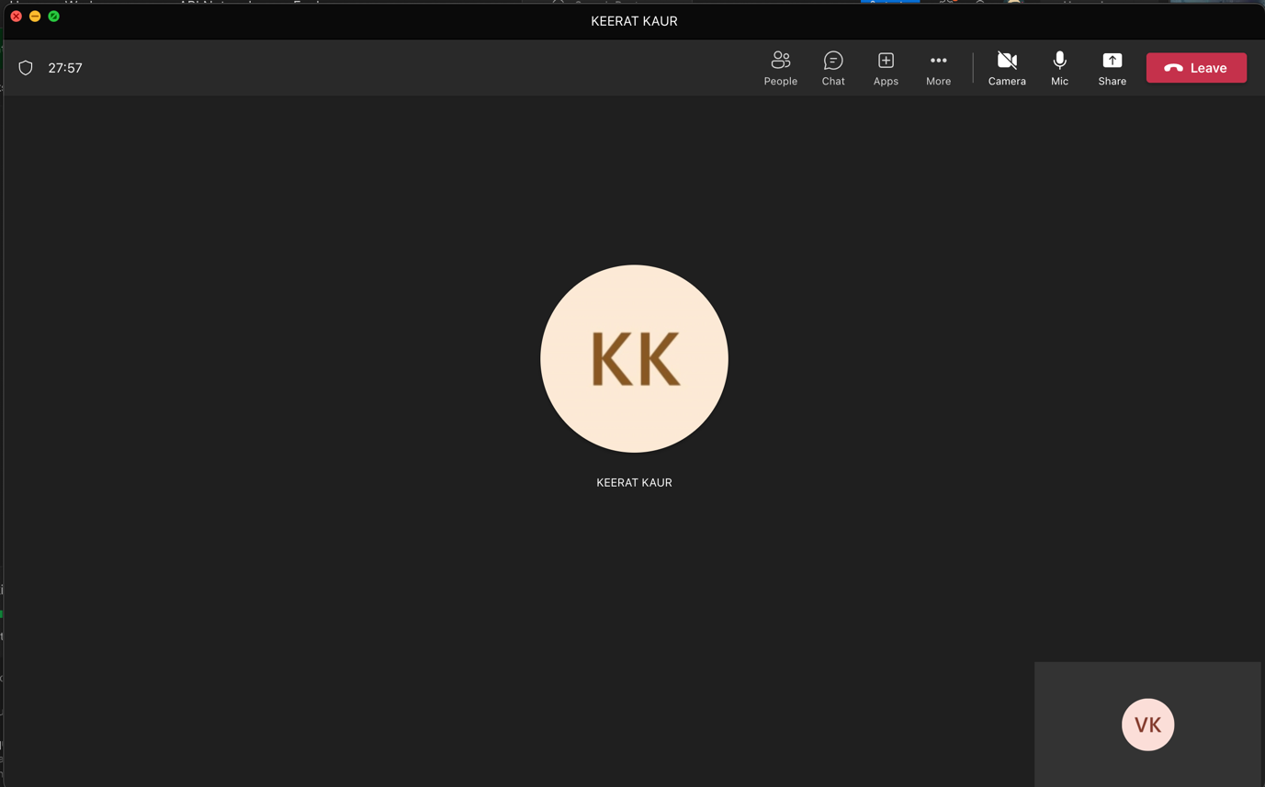

Figure 44: Meeting with Keerat to discuss about the issues

* Research on input audio config with Postman, and working on Postman audio config

<https://searchcode.com/file/326561264/samples/detect.js/>

<https://pkg.go.dev/github.com/ilisin/genproto/googleapis/cloud/dialogflow/v2#AudioEncoding.String>

## Thursday (15/12/2022)

* Join Week 6 Lecture Class
* Meeting with Keerat discuss about the documentation and sent audio file

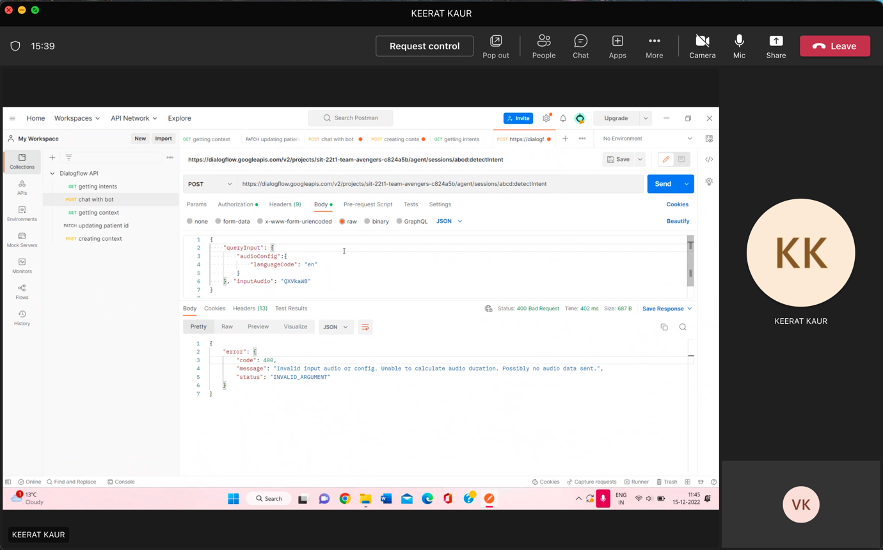

Figure 45: Meeting with Keerat to discuss about our task

## Friday (16/12/2022)

* Working on encoding audio file, and able to test the Speech-to-text function on Postman

<https://cloud.google.com/dialogflow/es/docs/how/detect-intent-audio#detect-intent-audio-drest>

<https://cloud.google.com/speech-to-text/docs/base64-encoding#windows>

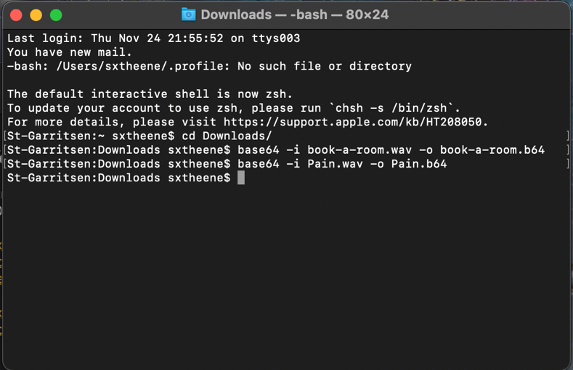

Figure 46: Encode audio file from wav to b64 using command

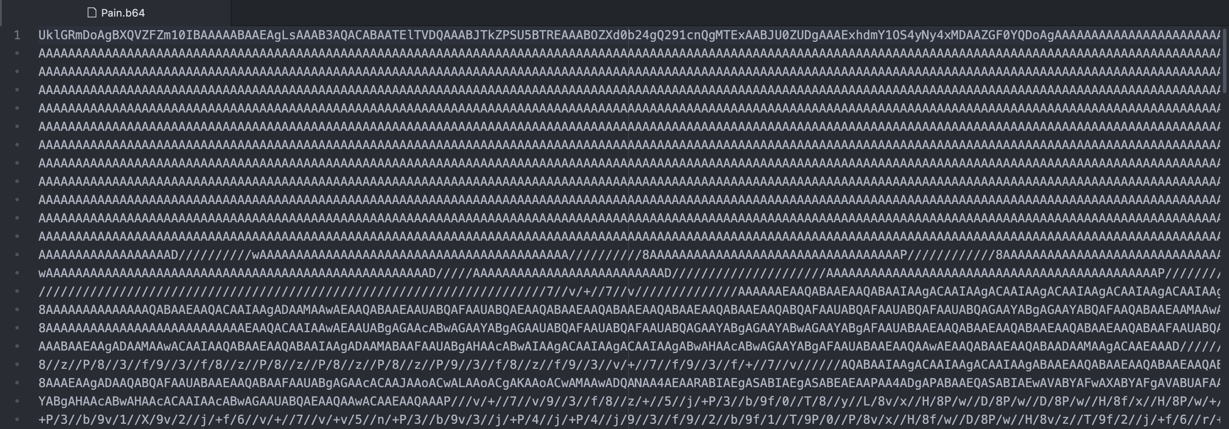

Figure 47: Encoded output file save as Pain.b64

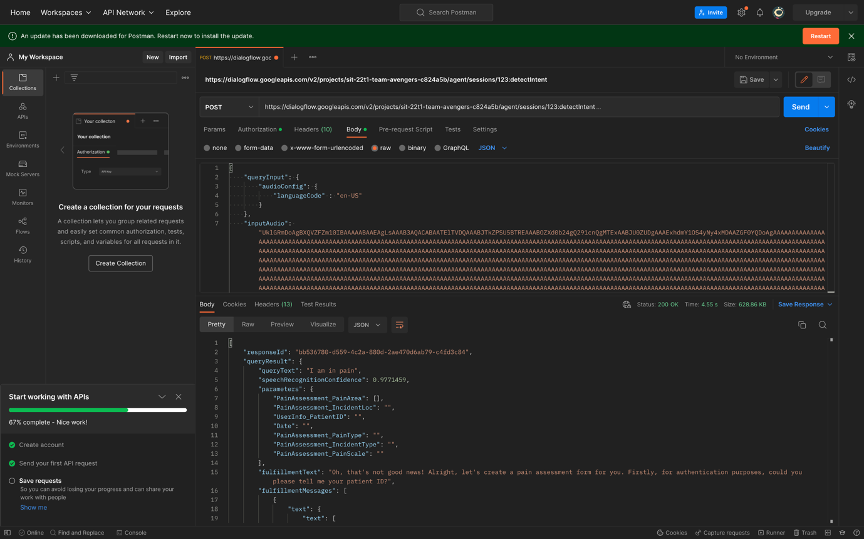

Figure 48: Able to testing the Speech-to-text function on Postman

* Join a meeting with Keerat to demonstrate how we able to test the Speech-to-text function on Postman

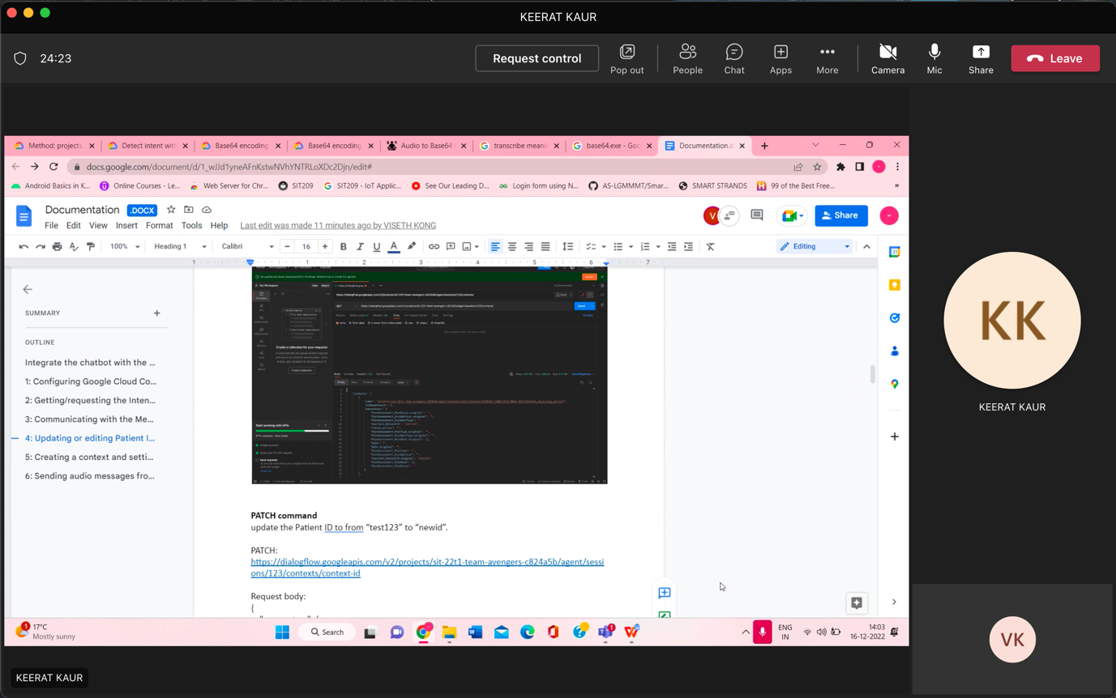

Figure 49: Meeting with Keerat to demonstrate how we work on the testing